Robtix Trossen Robotics Serial Driven Pan and Tilt Protocol Document
By: mewgen

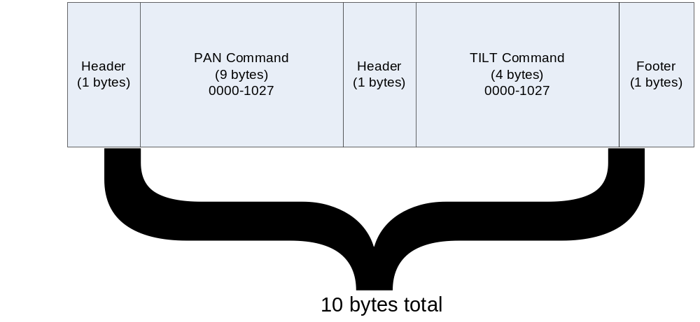

Ascii value | Hex Value | Byte position (base 1) | Description
Headers
: | 0x58 | 1 | Start of packet (must use)
Command
0000-1023 | 0x48,0x48,0x48,0x48 to 0x49,0x48,0x50,0x51 | 2-5 | Move to step increment or absolute position of the servo (note this must be 4 bytes long)
, | 0x44 | 6 | comma separator between the pan and tilt step commands
0000-1023 | 0x48,0x48,0x48,0x48 to 0x49,0x48,0x50,0x51 | 7-10 | Move to step increment or absolute position of the servo (note this must be 4 bytes long)
Footer
; | 0x59 | 8 | end of packet (must use)

Usage Examples:
To move pan motor to 0000 and tilt motor to 0400 if possible
:0000,0400;

To move pan motor to 0600 and tilt motor to 0850 if possible
0600,0850;

To center both servos if possible
:0512,0512;

To send a sequence of commands simply add on more commands as above and they will all be done in order. If you want to pause in between the you should do this in the code calling the turret
:0200,0200;:0800,0800;:0200,0200;:0800,0800;

Notes:
- The min tilt is 160, although it can actually move to 140 if you move very slowly
and max is 850, although it can move to 866 if you move very slowly
If these are attempted to be exceeded the value of the tilt will be corrected so it is within these bounds

- A command like:
:08A0,0200;
or
:123,123;
will be ignored since valid commands are :
pppp,tttt;
where pppp is characters between 0000 and 1027
and where tttt is characters between 0000 and 1027
values above 1027 (i.e. from 1028 to 9999) are rounded to 1027
values which are not numeric make the whole packet invalid and it is discarded until the next packet comets along

